# Session 8 – ENFORCEMENT & EFFECTIVENESS OF LAW

# 1. Adversarialism

* Recap of significance of, and key characteristics relating to:
* Judge
* Advocates (lawyers)
* Parties
* Procedure
* The effectiveness of any law depends on it being able to be enforced. How good is the adversarial model of justice for enforcing our laws and making them effective?
* What factors prevent the adversarial system from being effective – in other words, what are the barriers to justice?
* We will cover some of the main ones – though necessarily incomplete.

# (a) Barriers: Cost

* Main costs of accessing legal services: lawyer/barrister fees and (for litigious matters) court fees. But what are the other incidental costs?
* What is the problem with costs?
* Obviously limits the ability to obtain justice for those who cannot afford the fees
* But it has broader implications too, even when parties *can* afford the fees. Consider ***Seven Network Limited v News Limited*** [2007] FCA 1062 – an example of ‘mega-litigation’.
* The costs implications of the win/lose adversarial framework
* Costs indemnity rule: losing party pays successful party’s costs on a party/party basis
* Party / party basis: costs regarded as what is ‘reasonably necessary’ - not everything that lawyer has charged

# (b) Barriers: Formalities

* Impact disproportionately on members of the community that are already vulnerable
* Do they serve a (valuable) purpose? Consider:
* Movement to reduced formalities when Family Court was originally created – and subsequent events of the early 80s
* Accused person v resources of the State

# (c) Barriers: People

# *Judges*

* Importance of an independent and quality judiciary to an adversarial system is obvious
* Can we be confident of the quality of our judiciary?
* The appointment process often comes under scrutiny here – in practice does it ensure such independence and quality*?*
* Executive responsibility and [largely unformalised](https://www.ag.gov.au/LegalSystem/Courts/Pages/Courtappointments.aspx):
* Criticisms: subjective, closed process, unreviewable. Consider the ‘scandal’ over the appointment of the (now resigned) Chief Justice of the Queensland Supreme Court Tim Carmody. Consider also the fallout from the Dyson Heydon scandal of 2020 and the [calls for appointments reform](https://auspublaw.org/2020/06/will-the-heydon-scandal-finally-produce-judicial-appointments-reform/?utm_source=rss&utm_medium=rss&utm_campaign=will-the-heydon-scandal-finally-produce-judicial-appointments-reform) that it has provoked.
* The ‘merit’ debate
* What is it? “Merit” has never been formally defined.
* Traditional method *assumed* to deliver merit. Is the assumption well-founded?
* Push for greater diversity. What are the arguments?
* First argument**:** enhances the public’s confidence in, and respect for,the judiciary.
* Second argument:greater diversity on bench means a range of perspectives brought to bear on litigated issues, which enhances quality of decision-making.
* Judicial ‘key performance indicators’?
* Parliament and Executive normally very reluctant to state what Judges ‘should’ be doing;
* Judges in some jurisdictions attempting to take the lead in defining merit by adopting and making public their own performance indicators. See eg the [UK framework](https://www.judiciary.uk/publications/framework-of-judicial-abilities-and-qualities/).

# *Other parties*

* Self-represented litigants (SRLs)
* Why do we have them?
* Face great difficulties trying to navigate the adversarial system
* Pose considerable burden on court resources (judges, court staff, time) as well as the rights of other users of the system
* Courts and tribunals are doing their best to manage – a huge issue for them.

# *Powerful / wealthy opponents*

* Other end of the spectrum - powerful / wealthy litigant for whom neither cost nor complexity/formality of the adversarial system poses a problem.
* Adversarial system built on the idea of 2 (or more) relatively equally balanced parties presenting their case in the best light – what happens when parties not on equal footing?
* Famously explained by Marc Galanter in his article: ‘Why the 'Haves' Come Out Ahead: Speculations on the Limits of Legal Change’ (1974) 9 *Law & Society Review* 95 – identified ‘One-Shotters’ (‘OS’) and ‘Repeat Players’ (‘RP’). See Figure 1 below.
* Sometimes parties *are* evenly balanced, but whenever you have a OS facing a RP, likely result is that OS is at a considerable disadvantage.

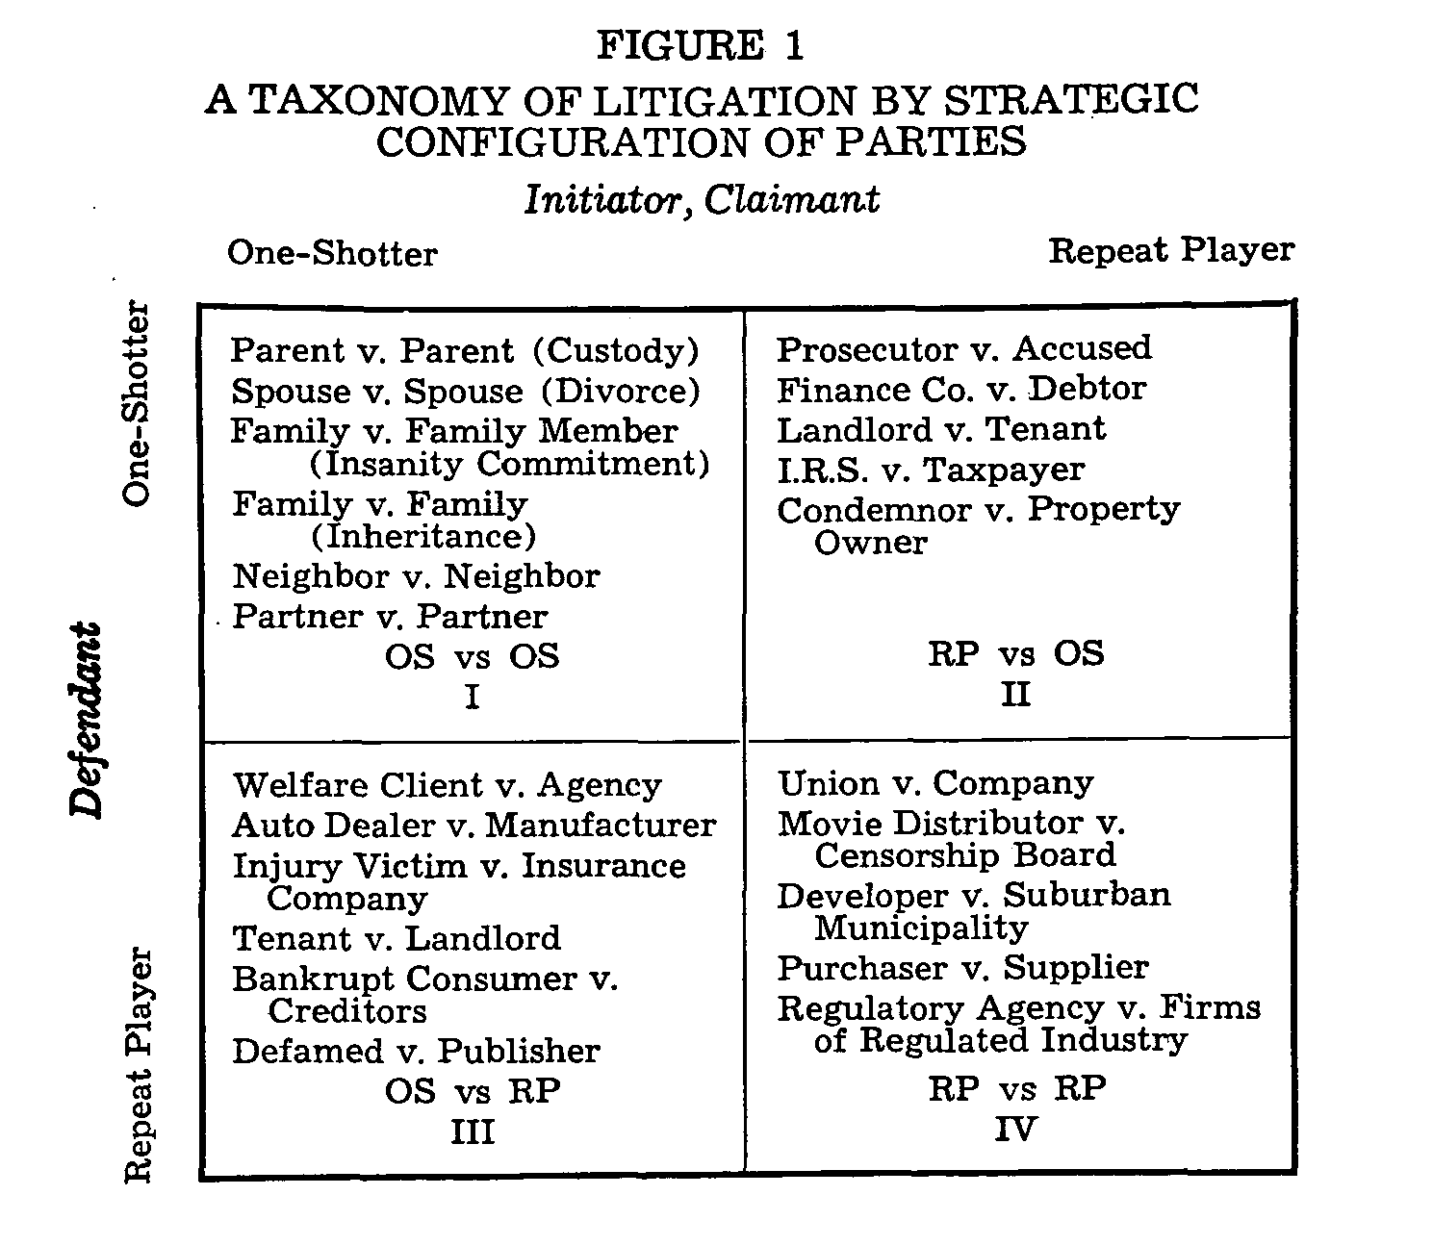

# 2. Steps to overcome the barriers inherent in the adversarial system?

# (a) Access to a lawyer

* Right to representation? No – only ***some*** rights to legal representation in ***some*** circumstances. See *Dietrich v The Queen* (1992) 177 CLR 292.
* Legal Aid
* Very limited availability
* Community legal centres
* Assist in representation but also research, lobby, campaign, educate, etc
* Now face considerable pressures which threaten that ideal
* Private lawyer - pro bono

# (b) DIY kits

* We now see informative websites, handbooks, ‘DIY kits’, simplified forms, hotlines, ‘how to’ guides, etc - to help people navigate their way through the system.
* For some, this information can take them a long way. But never the same as *advice*. And for others who face language/understanding and access obstacles, won’t take them far at all.

# (c) ADR

* ‘Alternative dispute resolution’ processes – ways of sorting out a dispute other than going to court eg. conciliation, mediation and arbitration.
* Now widely part of the general litigation process - misleading to call these ‘alternative’.
* Positive story is widely promoted – what about the negatives?

# (d) Problem-solving courts

* Trying to address access to justice issues in holistic sense eg Neighbourhood Justice Centre in Yarra.
* Influenced by therapeutic jurisprudence and aim to address “underlying causes” of offending behaviour / legal problems by linking to non-legal services (eg drug treatment or mental health services) and having a less adversarial courtroom with increased interaction between judge and individual.
* Recognition that people with high ‘legal need’ actually need a (mostly) non-legal solution
* Not suitable for all disputes/problems. But for some areas (especially crime) an effective adjunct to the adversarial system.
* The ACT has [recently established a Drug and Alcohol Court](https://justice.act.gov.au/justice-programs-and-initiatives-reducing-recidivism/building-communities-not-prisons/drug-and), with the aim of reducing reoffending among substance-addicted people in the Territory’s criminal justice system.